SQL Joins
Consider the following tables of instructors and courses (script to create this schema is given in Appendix A)
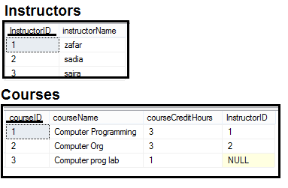

Inner Join

Instructors and Course table
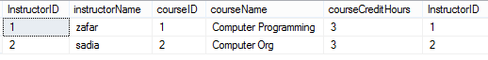

Left Outer Join

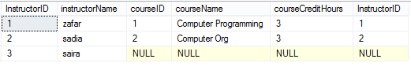

Right Outer Join
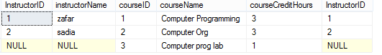

Full Outer Join

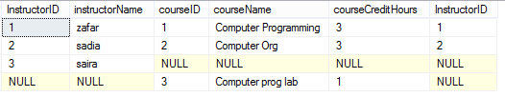

Cross Join

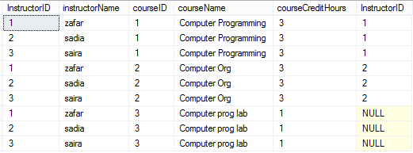

Join more than two table
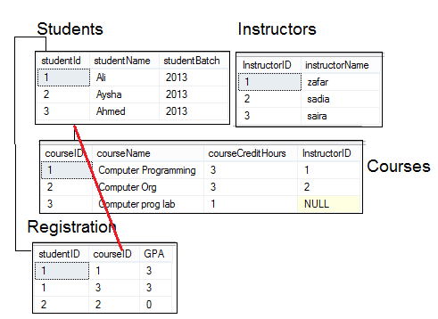

--show the name of all the students
--and the name of the course they are registered in
--and the name of instructors teaching that course

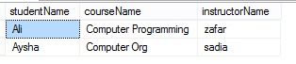

--show the name of all the students (regardless they are registerd in anycourse or not)
--and the name of the course they are registered in
--and the name of instructors teaching that course (if no instructor is assignd show -)

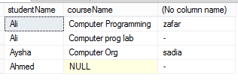

Appendix A
Schema for Practice
createtable Students
(
studentId intprimarykey,
studentName varchar(50),
studentBatch int
)
go
INSERTINTO Students VALUES (1,'Ali', 2013),(2,'Aysha',2013),(3,'Ahmed',2013)

go
createtable Instructors
(
InstructorID intprimarykey,
instructorName varchar(50)
)
go
insertinto Instructors values (1,'zafar'),(2,'sadia')
insertinto Instructors values (3,'saira')
go
createtable Course
(
courseID intprimarykey,
courseName varchar(50),
courseCreditHours int,
InstructorID int
)
insertinto Course values(1,'Computer Programming', 3,1),
(2,'Computer Org',3,2),
(3,'Computer prog lab',1,null)

go
createtable Registeration
(
studentID intforeignkeyreferences students(studentID)notnull,
courseID intforeignkeyreferences course(courseID)notnull,
GPA float
)
go
altertable registeration addprimarykey (studentID,courseID)
go
insertinto Registeration values(1,1,3.0),(1,3,3.0),(2,2,0)
go

